**Test Document**

**Project:** LIBERTY

**Document Version Number**: ***TEST - 01***

**Date: 22/10/2017**

**Author:** Edward Son

**Edit History:** N/A



# TABLE OF CONTENTS

**TABLE OF CONTENTS** **2**

**1. TESTS** **3**

2.1 Light sensor tests 3

2.2 Ultrasonic sensor tests 7

**2. Source Code used** **9**

**3. Hardware used** **9**

# 1. TESTS

## 2.1 Light sensor tests

Test 1: Characterization of a black line detection

Date: 17/10/2017

Tester: Andi-Camille Bakti

Author: Edward Son

1. This test will validate the functionality of these sensors when detecting black lines, in order to confirm that they can be used in the final design as a correctional light sensors.
2. This test should measure the moment the sensors detects a black line using RGB sensor mode.
3. The speed of the motors shall be of 50 deg/sec and the sampling frequency shall be set to 20Hz (or every 50 ms). No filter shall be applied to the readings of the sensor. The robot is placed half a tile away from the line (15.2 cm away) and with its wheel axle parallel to the line. The tester then selects the sensor that they are testing (either the ultrasonic sensor or color sensor). The test should end once the robot crosses the line and has traveled the length of one tile (30.48 cm) where the tester stops the program.
4. Modelling the data should show a relatively even line when the sensor is not seeing a line, and a clear dip in the values as the sensor passes over a black line.
5. Results:
   1. Purple light sensor: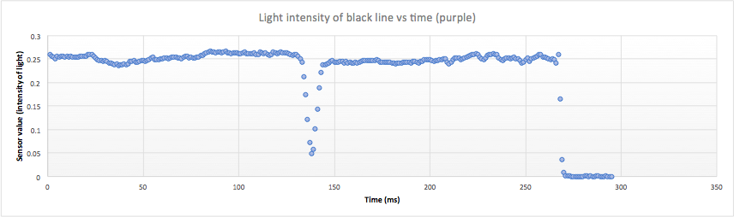
   2. Yellow light sensor:

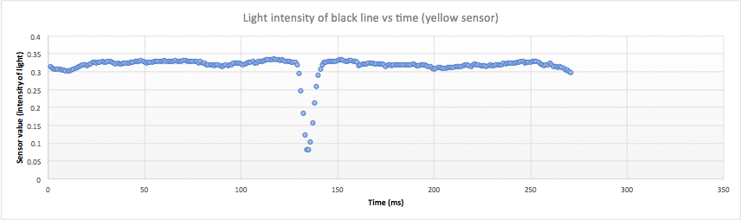

* 1. Red light sensor: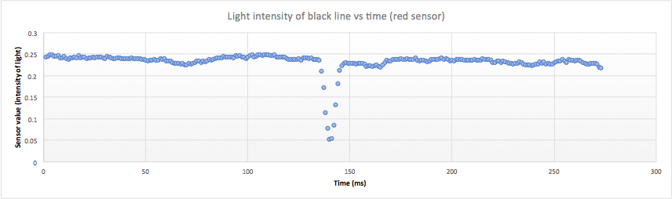

1. All three sensors satisfyingly detect a black line, as the graphs show. There is a noticeable dip in the data acquired.
2. All three sensors can be used for line detection in the final design.

Test 2: Characterization of wall detection

Date: 17/10/2017

Tester: Andi-Camille Bakti

Author: Edward Son

1. This test will validate the functionality of these sensors when detecting a wall/object, in order to confirm that they can be used in the final design to detect when the robot nears a wall/object.
2. This test should measure the moment the sensors detect a wall using RGB mode, allowing us to get an idea of the threshold before it sees nothing but black.
3. The speed of the motors shall be of 50 deg/sec and the sampling frequency shall be set to 20Hz (or every 50 ms). No filter shall be applied to the readings of the sensor. The robot is placed one tile away from the wall (30.48 cm away) and with its wheel axle parallel to the wall. The tester then selects the sensor that they are testing (either the ultrasonic sensor or color sensor). The test should end once the robot has hit the wall and has traveled the length of one tile (30.48 cm) where the tester stops the program.
4. Modelling the data should show a relatively even line when the sensor is not seeing a line, and a clear dip in the values as the sensor passes over a black line.
5. Results:
   1. Purple light sensor:

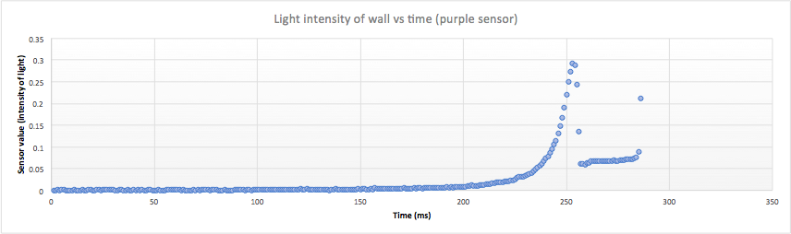

* 1. Yellow light sensor:

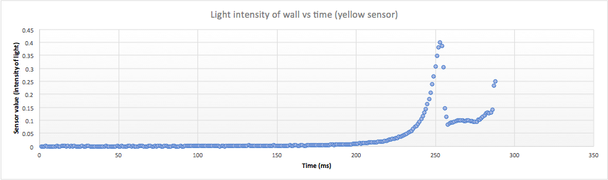

* 1. Red light sensor:

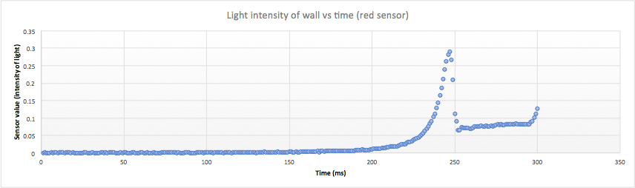

1. All three light sensors have detected a wall, as portrayed by a rise in the intensity until it reached a maximum, and then dropped to a constant value.
2. All three of these light sensors can be used to determine when the robot is against an object.

Test 3: Characterization of a blue block detection

Date: 17/10/2017

Tester: Andi-Camille Bakti

Author: Edward Son

1. This test will validate the functionality of these sensors when detecting color, in order to confirm that they can be used in the final design to detect the color of the flag.
2. This test should measure the moment the sensors detects the right color of a block using RGB sensor mode.
3. The speed of the motors shall be of 50 deg/sec and the sampling frequency shall be set to 20Hz (or every 50 ms). No filter shall be applied to the readings of the sensor. The robot is placed one tile away from the block (30.48 cm away) and with its wheel axle parallel to the block. The tester then selects the sensor that they are testing (either the ultrasonic sensor or color sensor). The test should end once the robot has hit the block and has traveled the length of one tile (30.48 cm) where the tester stops the program.
4. Modelling the data should show a relatively even line when the sensor is not seeing a line, and a clear dip in the values as the sensor passes over a black line.
5. Results:
   1. Purple light sensor:

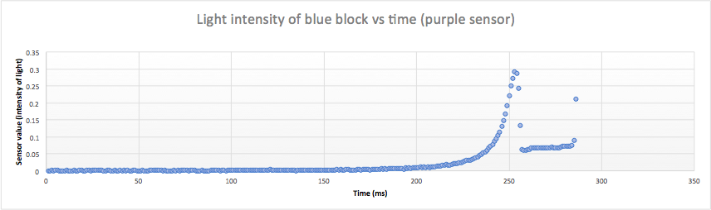

* 1. Yellow light sensor:

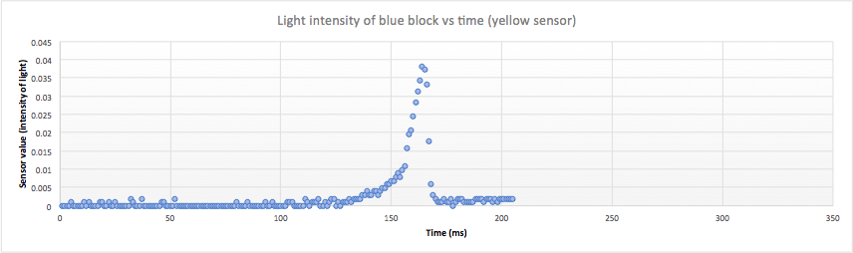

* 1. Red light sensor:

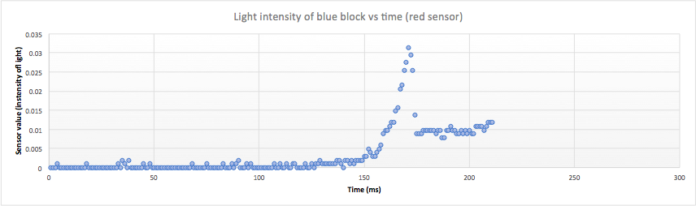

1. All three light sensors have detected the coloured block as shown by the peak in the graphs.
2. All three light sensors can be used to detect a coloured block. However the intensity reported by the Yellow light sensor facing the wall directly is close to 0, which indicates the ideal scenario of directly hitting an object head-on. The measurements of the purple and red light sensor better reflect what would happen outside of a test scenario.

## 2.2 Ultrasonic sensor tests

Test 4: Characterization of wall detection

Date: 17/10/2017

Tester: Andi-Camille Bakti

Author: Edward Son

1. This test will validate the functionality of these sensors, in order to confirm that they can be used in the final design as a primary ultrasonic sensors.
2. This test should measure the distance from a wall as the sensor gets closer directly in front of it.
3. The speed of the motors shall be of 50 deg/sec and the sampling frequency shall be set to 20Hz (or every 50 ms). No filter shall be applied to the readings of the sensor. The robot is placed one tile away from the wall (30.48 cm away) and with its wheel axle parallel to the wall. The tester then selects the sensor that they are testing (either the ultrasonic sensor or color sensor). The test should end once the robot has hit the wall and has traveled the length of one tile (30.48 cm) where the tester stops the program.
4. Modelling the data should show a linear function slowly decreasing until it reaches zero meters.
5. Results:
   1. Purple light sensor:
   2. Yellow light sensor: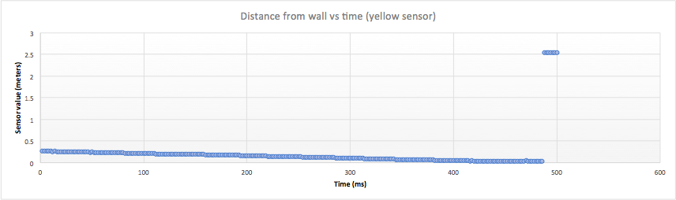

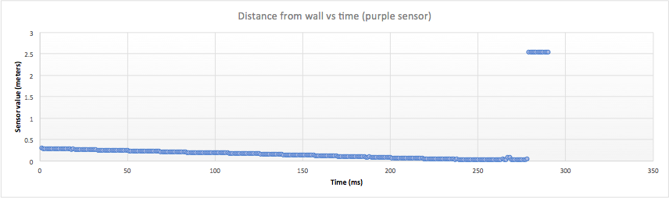

1. The results indeed model a negatively sloped linear motion, which reaches zero, and then rises immediately to 2.55 meters. This is due to our data filtering, which caps maximum values at 2.55 meters. When the sensor is against a wall, the values become inaccurate and large, which is why the data shows a sudden jump to 2.55 meters.
2. Both these ultrasonic sensors can be used as a primary ultrasonic sensor in the final design, used for localization and obstacle detection.

# 2. Source Code used

See github group repository at commit: 625beeea9869238d5f9ba3f398188be2df3ae12e

# 3. Hardware used

